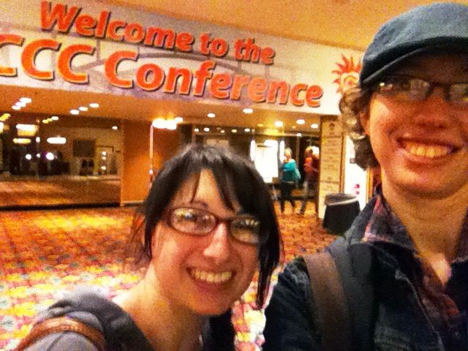

Sandra and Alyssa-Rae arrive at C’s 2013 at the Riviera Hotel!
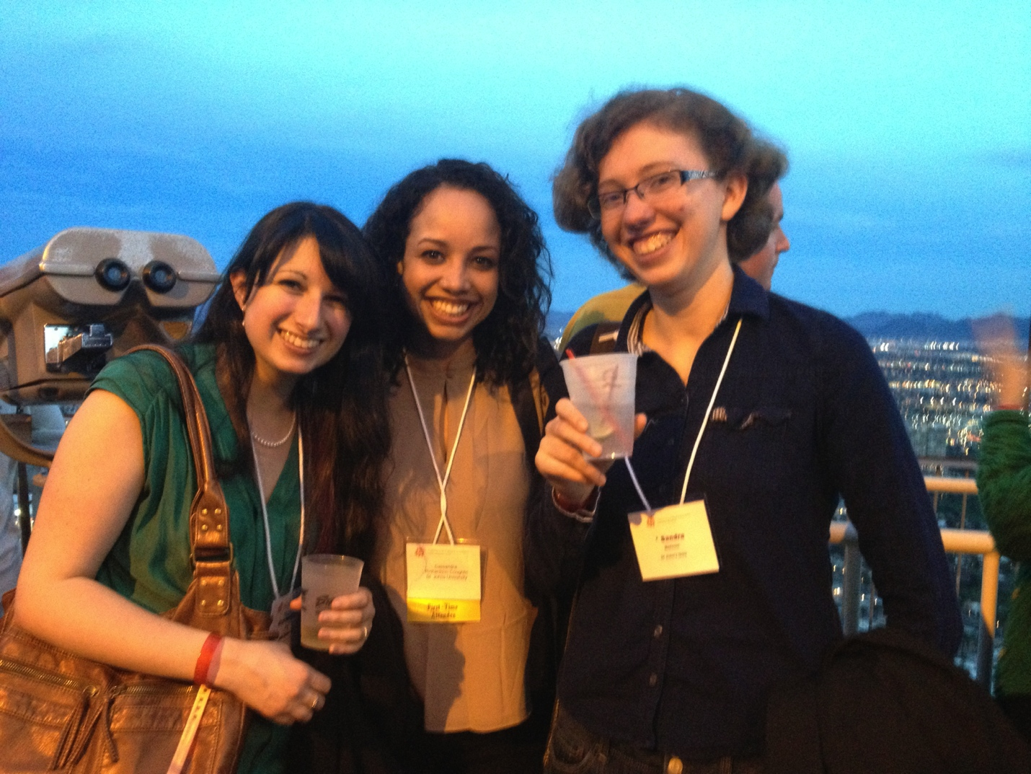
After a day of independently going to panels that spoke to their interests in Writing and Rhetoric, ranging from including Othered voices and ways of writing in the classroom and writing studies, to theories of transfer, to the fascinating and influential research conducted by our own St. John’s faculty and students, Sandra, Cassandra, and Alyssa-Rae attended the CCCC Bedford-St. Martin party at the top of the Stratosphere. Behind Sandra is a beautiful view of all of Las Vegas.

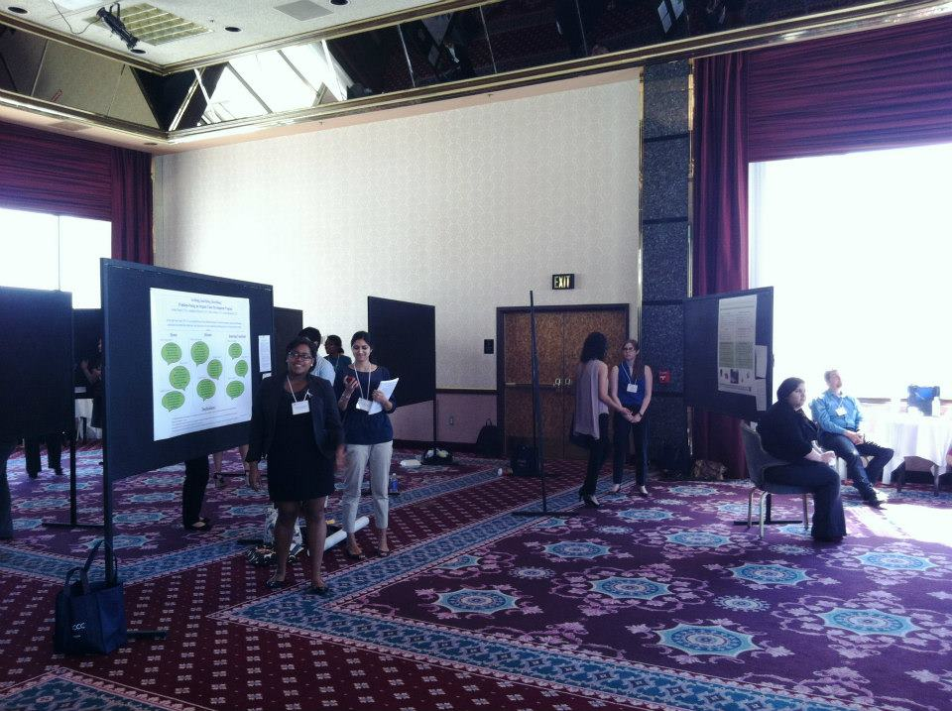
Josie, Jonaki, Pedro, and Noshee presented their research on the University Writing Center’s new “mentor” training program for new hires at the C’s Undergraduate Poster Session. They explored the positives and negatives of the experience from interviews with new hires, mentors, and non-mentor senior consultants.

