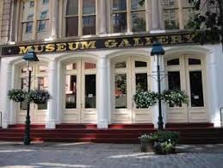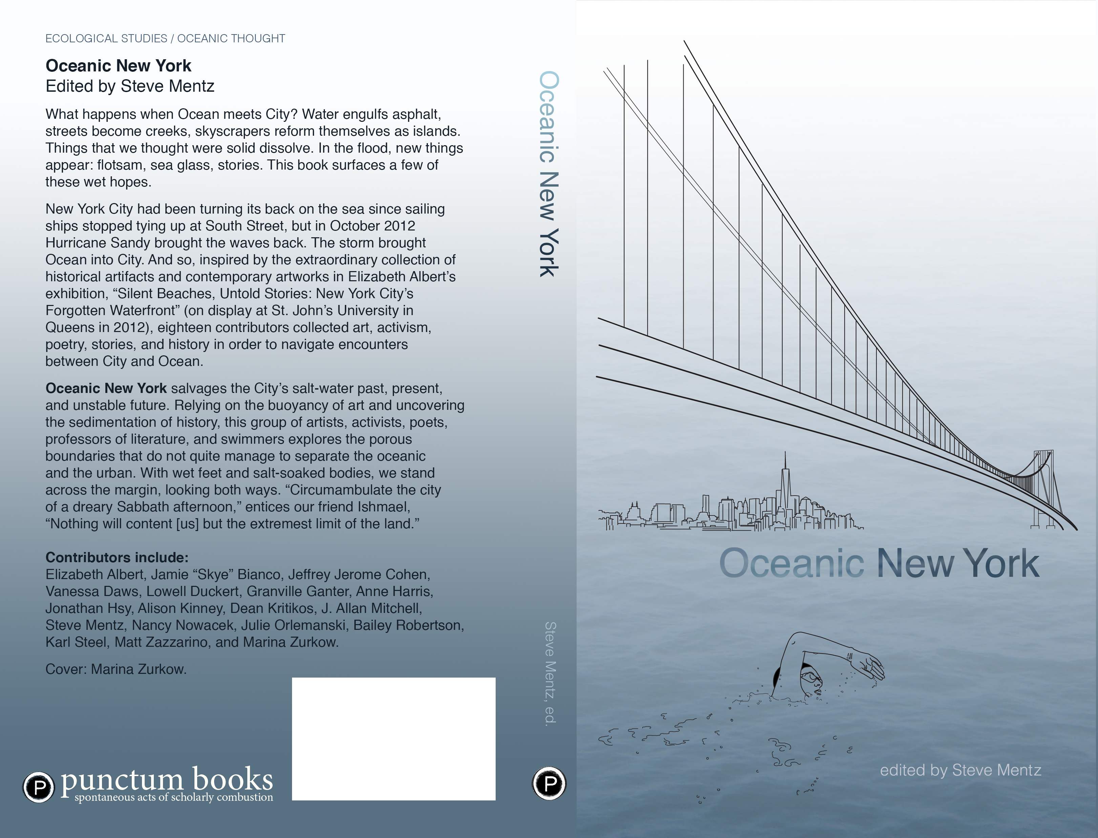

# Come to a Book Party for

# *Oceanic New York*

# edited by

# Steve Mentz

*Cover image by Marina Zurkow*

*Co-hosted by St. John’s University and Underwater New York:* [*www.underwaternewyork.com*](http://www.underwaternewyork.com)

* **The Melville Gallery at South Street Seaport Museum**
* **213 Water Street, Manhattan**

Thursday, November 5th, 2015 from 7:00 – 9:00 p.m.

at The Melville Gallery

**Oceanic New York**