The English Department at
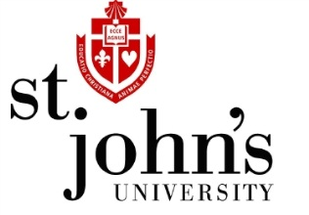
Invites Graduate Students and Faculty to a
Reception and Blog Launch!
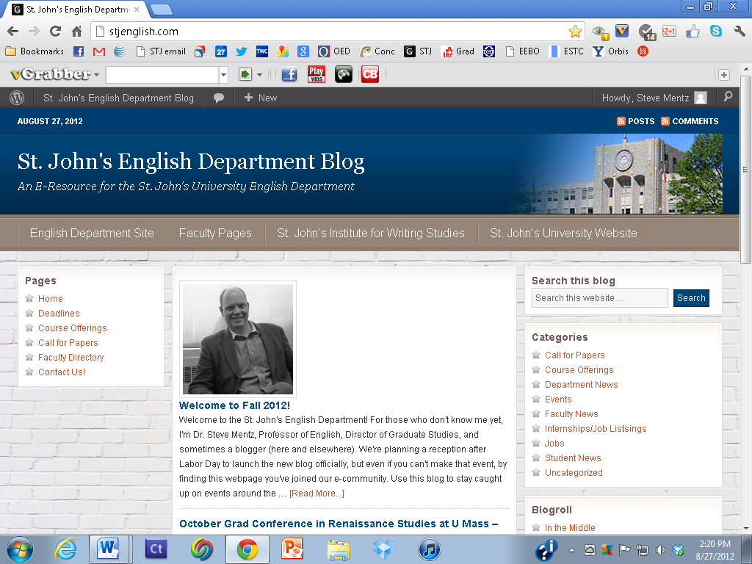
Thursday, September 6
6 – 8 pm, with a short blog presentation at 7 pm
Institute for Writing Studies
Light Refreshments will be served

