St. John’s University English Department
Summer 2020 Graduate Course Flyer

Summer Session 1: June 1 – July 2, 2020
E 790: Drama and Society: Staging the Coming Storm (31296)
Dr. Steve Mentz
Email: mentzs@stjohns.edu
Performance: The Tempest, Shakespeare on the Sound, Rowaytan CT (June 18 – July 5)
How can art and literature respond to ecological catastrophe? This course takes as our case study a new outdoor production of Shakespeare’s The Tempest, which we will put in dialogue with eco-theory, environmentalist activism, ideas about local art practices, and a series of Field Seminars to the polluted waterways of New York City, the rehearsal room of Shakespeare on the Sound’s production of The Tempest, and perhaps, if we can work out the logistics, a canoe trip on Newtown Creek. Literary readings beyond Shakespeare will include modern responses to The Tempest by Aime Cesaire, Rachel Ingalls, Kamau Brathwaite, and others. Readings in eco-theory will include Kathryn Yussof’s A Billion Black Anthropocenes or None, Lewis and Maslin’s The Human Planet, and Steve Mentz’s Break Up the Anthropocene. Readings in public environmental activism will include local New York writers such as Mary Heglar and Genevieve Guenther as well as global figures such as Bill McKibben and Sheila Watt-Cloutier. One of our projects will be to learn the language of Land Acknowledgments and consider how Indigenous knowledges can support current thinking about our environment.

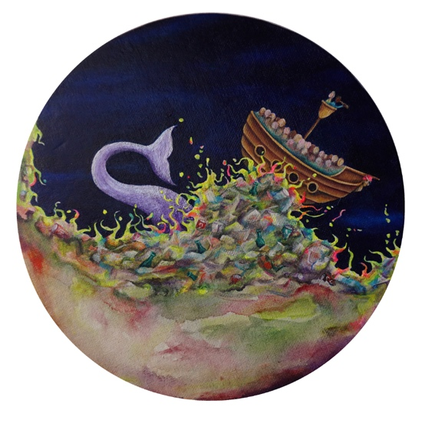
Summer Session II: July 6 – Aug 6
ENG. 100: Introduction to Modern Critical Theory (30844)
Questions of Relevance
ONLINE
Dr. Melissa Mowry
Email: mowrym@stjohns.edu
This class will focus on the centrality of cultural and literary criticism in the West to the project of deconstructing authoritarianisms in the post-war era. We will begin with Michel Foucault’s Discipline and Punish, include some Derrida. From there we will move on to engage with a variety of post-colonial interventions, radical democratic politics, the interventions of critical race theory, as well as current work on rethinking the possibilities of collectivity beyond the social. This class is fully on-line. There will be bi-weekly, graded discussions on the material as well as a final 15-page paper on a mutually agreed-upon topic.

